To The Smallest 2026 Tournament Pack v1.1
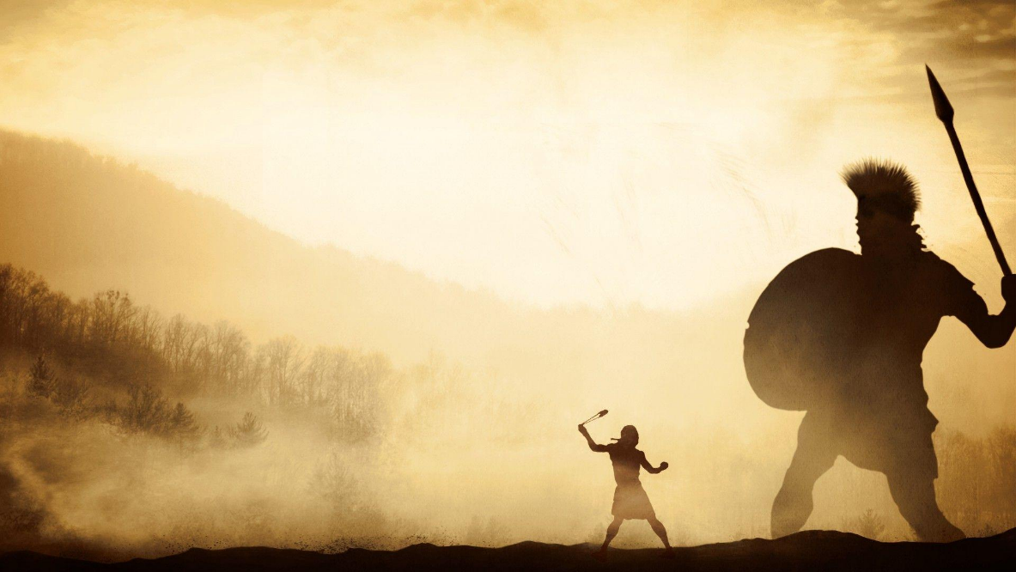
The table will be the standard 6’ x 4’ table but with 4” (100mm) sized boxes/squares rather than the normal 6” (150mm) ones to prevent this being just another TTS game with smaller figures.
The tournament will take place on Saturday 25 July 2026 at Firestorm games.
Play testing has taken place and tournament amendments made, so hopefully there should be no major issues. If you see any glaring issues in the below, please let me know by email on sidney120@virginmedia.com
Army lists are to be submitted by 6 July 2026 to the above email for ratification. If there are players you wish to avoid for reasons of hygiene, being a relative, club mate or simply out of fear for their awesomeness etc please include that with your lists.
This year any army without any mounted lance unit units (light cavalry, Cavalry, Knights, Later knights, Light Camels, Camels, Chariots or Heavy Chariots) can request to play their first match on a terrain heavy table. Make the request when you submit your lists.
Looking forward to seeing you all.
All the best
Sid

Contents
Page 3 – Scoring System
Page 3 – Location
Page 3 - Timetable
Page 4 - Chits and Cards
Page 4 - Terrain and Mats
Page 4 - Stratagems
Page 5 - Pre-game complements
Page 5 - Placement of heroes
Page 5 - Pre-set terrain for all games
Page 6 - Tournament Rules Amendments
Page 6 - Army Lists
Page 6 - Rules queries
Page 6 - Final Words
Page 7 – Appendix

1 - Scoring System
The scoring system will be similar that used in Godendag this year to show a continuity between tournament scoring. The only difference being a bonus of +25 points not +50 for a complete win.

This is the is the system pioneered by Peter RYDING, so his contribution is whole heartedly acknowledged. Although it has been tweaked to make a complete victory giving slightly less points than the original.

All you need do is complete the scoring slip and let the Tournament Organiser do the rest.
It is the responsibility of the winning player (or failing that the player who took the most coins) to hand in the match slip. This needs to be done as soon as possible to keep things moving.
2 – Location
The event will be held at Firestorm Games, 66 Sloper Road Cardiff CF11 8AB. Parking can be limited so the earlier you arrive, the better. Lunch is included in your entry price and there is a bar/café on site. There is also free guest wi-fi onsite.
There is a gathering of players on the Friday night of those who have travelled down the night before and sometimes get a practice game in or simply talk nonsense with old friends. Firestorm is open until 10pm. so sometimes folk have a curry in town or simply game and use the on-site café.
Players who want to game on the Friday will have to purchase a casual play ticket online, directly from Firestorm Events the Battlefields. Any issues with this nearer the time, let me know and I can send you a link. The casual play tickets are not normally available until just a week beforehand.
3 - Timetable
Saturday 25 July 2026
- 0830-0850 Registration and set up
- 0900-1100 Round One
- 1115-1315 Round Two
- 1315- 1345 Lunch and therapy
- 1345-1545 Round Three
- 1555-1755 Round Four
- 1800 Prize giving, followed by home for tea and medals. Yes, there are prizes/trophies, together with bragging rights.
10 minutes before the advertised end of each round, a bell will be rung and an announcement will be made of ‘Last round, time gentlemen please’. When the present turn is finished the game ends, unless it is the round of the player who went first, in which case the player who went second will finish his round so everyone gets the same number of turns.
Timings are flexible, insofar as if BOTH players are ready and willing to play before the announced time, they can go for it. However, end times are not flexible as we need to maintain momentum. The games are 2 hours so should allow a finish with the larger armies and tables. It should also allow some suitably acerbic banter during the games.
4 - Chits and Cards
Only cards are to be used at this tournament. Any player may challenge his opponent once during each game to show his cards to see if there are extra or less cards in his pack. If this happens, then please call the event organiser over (that’s Sid). This takes time, so please only do this if there are serious concerns during the game.
5 - Terrain and Mats
Arrangements have been made to provide terrain and maps. However, these are still limited, so if you have a 6x4 or even a 3x4 mat with 100mm squares, please let me know as soon as convenient via email.
The tables will be preset terrain based on historical battles (with adjustments for playability). Most will be terrain heavy but there will be the odd open table. Last year tables were based around Cannae, Kadesh, Teutoberger Wald, Thermoplylae, Issus, Towton and others. This year one of the tables will be an old school simultaneous deployment behind screens to simulate deploying in the mist which lifts as the armies advance.
6 - Stratagems
If BOTH players agree, then stratagems can be dispensed with. Otherwise, they are in play. All are obligatory except AMBUSH, RESERVES and FLANK MARCH, so for example ‘LOST’ appears to offer no benefit but must still be used. However, AMBUSH, FLANK MARCH or RESERVES are optional choices so may be dispensed with. If a unit is not initially deployed, due to any of the stratagems, a player does not have to say if RESERVES, FLANK MARCH, LOST or AMBUSH has caused the unit to be off table until it arrives. He merely states he has a unit not on the table and hands his opponents the appropriate number of medals. The player must have written which zone/flank a unit arriving as a reserve or flanking move comes on or where an AMBUSH is located. This is done before the first unit is placed on the table. I would suggest the stratagem have a piece of paper with it. A particular cunning player may have a piece of paper next to an unrevealed stratagem for LOST, just to obfuscate the issue.
Units not on table at the start of the game will enter the table for the first time (not re-entering) so will not be lost upon the draw of an ace.
It is good etiquette to place your own stratagem card/marker face down in your own camp. It also helps you not to forget that you have a stratagem in the heat of battle.
Similarly, if a JOKER is drawn, then the stratagem to be used is written on a slip of paper and placed in the camp. It is acceptable to put a piece of paper in your camp. even if you do not have a JOKER just to cause more confusion.
If a player has the THIS WAY EFFENDI stratagem, then the command is moved directly back up to three squares, not one. The number of squares being dictated by the person playing the stratagem and the command moved must all be moved the same number of squares. A unit cannot be moved back through impassable terrain.
Pre-game stratagems such as THIS WAY EFFENDI are declared and used in scouting order. So, before the first move the player who has won the scouting will use or decline use of a stratagem and then the non-scouting player.
7 - Pre-game compliments
At the start of the game, before scouting is decided, players will exchange their respective army lists for inspection by their opponent. The game will not be delayed for the players to go through the lists in detail, it is a courtesy to avoid surprises.
In similar vein, all units are to be fully described when placed on the table.

8 - Placement of heroes
Players can place heroes with units as they place units on the table or place them with units after all units have been placed on the table before the first activation card is drawn. Players can do this informally and just plop them down, or if one or both players wish to formalise the process, then each player (commencing with the out scouted player) will place down one hero, then his opponent and so forth placing them alternatively until all heroes are on the table.
Naturally heroes which come with their units such as warrior units are placed on deployment and do not form part of this process.
9 - Pre-set terrain for all games
All games will follow this format. Tables and opponents will be allocated by the tournament organiser. The first round will be historical match ups as much as possible, then follow a Swiss system.
Terrain will be slightly denser than normal on most tables to compensate for the advantages mounted armies might have on the larger tables.
As the 100mm squares result in a playing surface of 12 x 18 boxes rather than the normal 8 x 12 boxes then players will deploy up to 4 squares in not the normal 2, and the edge 2 boxes not just 1 will be outside the initial deployment zone. Deployment zones are shown in red on the diagram below.

10 - Tournament Rules Amendments
The main rules together with the latest ES will be in play. There will be the following deviations from the main rules.
- As noted above, the stratagems FLANK MARCH, RESERVES and AMBUSH will not be compulsory. Although players may put the stratagem chit face down in their camp to imply, they have something nasty up their sleeve.
- Units will not be permitted to voluntarily leave the table except when using stratagems. Units will still be able to evade off table. This is for two reasons, firstly to speed up play in what is likely to be a time sensitive event with the larger armies and table size, secondly to remove a potential advantage from mounted armies who will already benefit from the larger playing surface.
- Normally camps must be placed in orthogonal contact with other units in the command for which they are part of. For this tournament camps must still be on the baseline of your deployment area, but as deployment is up to 4 boxes in, this could lead to a caterpillar like chain of units to connect the camp to the battleline. Therefore, camps and any garrisons deployed within them at deployment do not have to be adjacent to another unit in their command orthogonally. However, the camp must be in a line behind one of the units in its own command.
- Troops may only dismount if specified in the rules or army lists.
11 - Army Lists
Armies will be 160 points and players are welcome to submit a list under 160 but anything over 160 is not permitted. All army lists in play at the time of submission will be permitted and optionally can be amended if new lists are published. The lists will be as written, and no change allowed for the larger than normal armies so for example players will still be capped to 4 generals which can create command issues for armies with large numbers of cheap units.
12 - Rules queries
If there are any rules disagreements, the tournament organiser will adjudicate. It is possible this might be wrong as he is only human after all (apparently) but feel free to wreak a terrible revenge on him via social media if he got it terribly wrong.
13 - Final Words
If anyone needs to get hold of me urgently, eg car broke down enroute, a last-minute withdrawal etc then feel free to email me on sidney120@virginmedia.com or call on 07809541395. These are for game related concerns only; I no longer offer financial advice or marriage guidance.

Appendix
In view of recent debates about rules interpretations the following is confirmed.
Moving or fighting across diagonals possibly construed as difficult terrain. A unit attacking from A to B does not enter either wood and counts the terrain box in which is starts and attacks which is only Boxes A and B. Therefore, if A and B are clear terrain the activation would only a diagonal move not difficult terrain.
The only stated exception would be if the two forests were deemed impassable then the diagonal between them is also impassable.
 | B
A

Any Unit moving or charging across from A to B will not count as moving into or through difficult terrain.
There has previously been a misunderstanding of ZOC across a diagonal. The facings of the units below are indicated by the direction of the arrow shape. If Red Unit 1 wishes to charge blue Unit A, it is permitted because it is attacking through the diagonal, it does not cross into the box impacted by the ZOC of blue unit B.
 |  | A
 | 1 | ZOC of unit B
 |  | B

Timing of heroes and other methods to replay to hit cards. Just to avoid confusion the following ruling is in place.
Some clubs say the time to decide to replay a to hit card is made before any bonus attacks are made. Other clubs play all to hit cards including bonus cards such as lance, flanking etc and then decide if they wish to replay the initial to hit card. For the Smallest, the second method will be in play.

