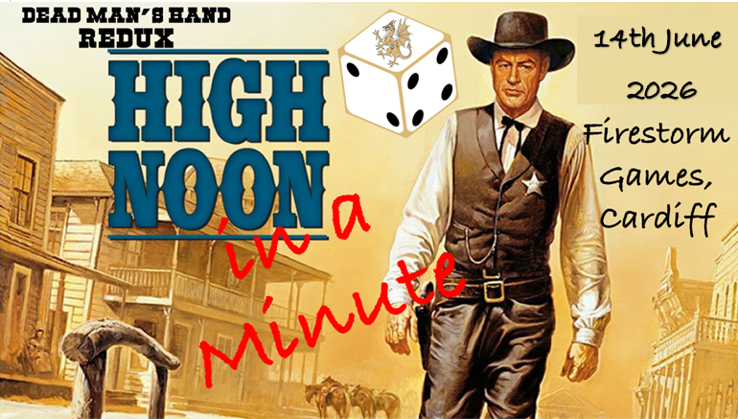
South Wales Warlords are proud to present our first Dead Man's Hand Tournament, High Noon in a Minute! We invite you to Firestorm Games (Sloper Rd, Cardiff, CF11 8AB) on Sunday 14th June 2026 to join us for 3 fun, action packed games full of friendly shootouts. Tickets are priced at £20 for the day, which includes a hot lunch.

Tickets for High Noon In a Minute:
High Noon in a Minute 2026 - High Noon: Reloaded Tournament

What to Bring
- A gang of up to 21 reputation.
- 2x copies of your gang list (the second is for your opponent to view).
- Your own D10 and D20 Dice, a card deck in both colours plus the special cards related to your gang, tape measure, Game tokens.
- A copy of Dead Mans Hand Redux rule book, plus a copy of any Dead Mans Hand Supplement books (if required).

Gang Selection
Players must build a gang to the following criteria:
- 21 Reputation
- Gangs from Dead Mans Hand Redux, or either of the Legend of Dead Mans Hand, or Dead Mans Hand Down under supplement Book may be used.
- Character Models may be used, providing the appropriate reputation is paid.
- Lists must be submitted by midnight of 22.06.24. Players who buy their ticket after this will be given a new submission date.
- Players will suffer a 2 point penalty for a list submission after this date.
- Any list that does not follow the above rules will be returned with an explanation and a new submission date if it is near or after the original submission date.
- Send final lists to joeclapham@hotmail.co.uk and you should receive a confirmation email.

Event Rules
- High Noon in a Minute will be using the rules, as written, from Dead Man’s Hand Redux.
- Mission pack being used on the day will be released on 22.06.24.
- Models tabled must be ‘WYSIWYG.’
- Models must be painted using a minimum of three colours.
- Games start and end when the TO has announced the timer has started and ended
- Game will be a total of 2 hours. Best efforts to discuss each other’s gangs should be made before this time starts.
- Should both opponents usually use the same coloured card deck, one player should use the alternative coloured deck with the addition of their gang specific cards.
- When the time has run out the game is over. No models should be moved or dice rolled after the timer ends.
- If there is a disagreement of any kind, players are urged to resolve it between themselves. Remember, this is a friendly event! However, a TO ruling can be asked for at any time.
- Points may be deducted if any of these rules have been broken.
- Gangs will reset at the end of each scene injuries and deaths will not carry through.

Timings, Match Ups and Scoring System
- Each game will last 2 hours, and will consist of 3 Scenes.
- Players will be matched at random for their first game.
- Players will move to the next board to the left for each of the remaining two games.
- Players will receive a point per Scene they win. They will also score a point if their gang is in possession of the secondary objective at the end of the 3 scenes.
- In the event that players are joint on points, gang members killed will determine the position.
- After players have finished their game, they need to collect a slip from the TO, fill in the information, and return it to the TO.

Time Table of the day
Doors open | 9:00
Registration | 9:00- 9:30
First Game | 9:30- 11:30
Lunch | 11:30- 12:30
Second Game | 12:30- 2:30
Third Game | 2:30- 4:30
Results | 4:45

Awards
- The Good (1st Good Gang)
- The Bad (1st Bad Gang)
- The Ugly (Wooden Spoon)
- “That’s a Dandy” (Coolest Gang)
- Best Trail Partner on the Prairie (Most Sporting)

Contact and More Information
Any further rule changes or highlights will be posted in good time before the event. If you have any questions please contact Joe by email at joeclapham@hotmail.co.uk or
Keep up to date on the event by joining the Facebook events at:

